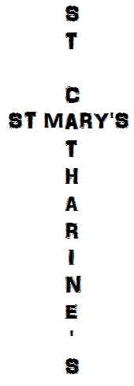

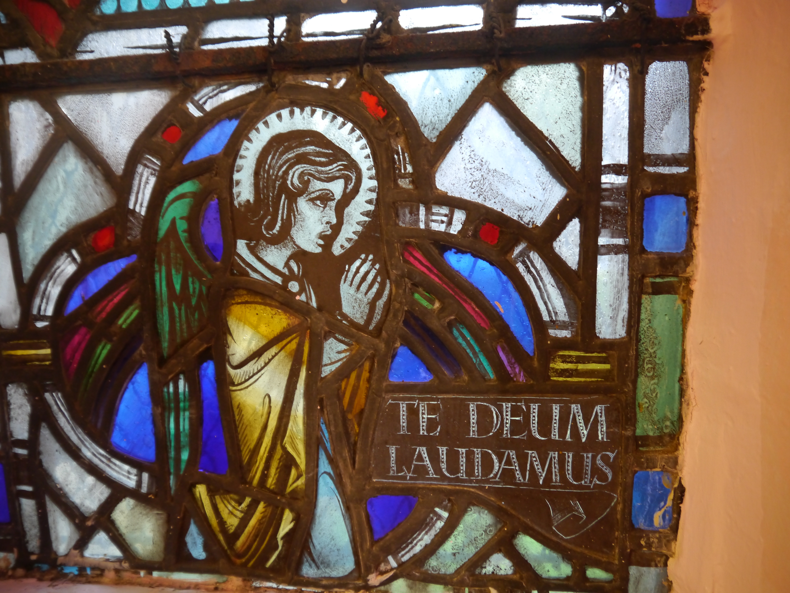

THE LINK, November 2020
“Jesus Christ is the same yesterday, today, and for ever.”
Hebrews 13:8

Dear church family,

This time of year is when special services start coming thick and fast and Advent and Christmas suddenly come upon you. It starts with All Saints, All Souls and Remembrance, has a week back in Ordinary time, and then it's Christ the King and the 1st Sunday of Advent. In between are two important saints associated with Scotland, St Margaret and St Andrew. Usually, this calendar would be directing our thoughts, taking us through the seasons, but today we are more likely to checking which tier of restrictions we are in today than preparing ourselves for the next Christian festival.

All the same, the liturgical calendar provides us with something solid to fall back on. The natural world does not know about the Coronavirus crisis – the leaves are falling thick and fast as usual this year, it gets darker in the same way it always does, the Christmas lights are still going up in our streets (okay, that's not nature). So many things are in fact the same.

Perhaps we are merely living closer to what the reality of daily life has looked like in many other places for many years: living under restrictions, dependent on decrees from the government over which we have no control, living with the reality that there is something which can harm you which you may have to face no matter how fully you try to avoid it. We are not facing conflict or famine or natural disaster as they are doing elsewhere, but we are reminded that we personally and as humanity are not fully in control of our own destiny. As much as we want many choices and value having the freedom to choose, the ones we actually can pick between have been much reduced over the last several months.

But we are always faced with the choice of following God or not, whatever outside circumstances there are, just as those Christians in other countries always have to do. We can always choose to pray or not. God is always there, not subject to change. He is more sure than the seasons. More necessary than bread. More secure than the largest bank account. We can still choose to spend our time well and fruitfully rather than just letting it pass.

Whatever you are facing at this moment, let it push you towards God. His love is constant. He has been faithful before and will not abandon us now. He is the solid, unshifting ground on which we can stand.

Blessings to you all,
Willie

NOTICES

This last month saw the death of our oldest member at St Mary's, Doreen Williams. The family have sent me links to various materials that were used during her funeral service – the whole service was recorded for instance along with a song written for the occasion by her family. If you would like to see any of the words or watch the service, please let Willie know and he will send you the links to them.

Susan, in her role as deacon, has made contact with the Kersiebank Project, currently based in the old Poundstretcher unit in Grangemouth Precinct. They have been operating a foodbank, but have recently had their funding removed, so are really struggling to provide for the need that they are facing. They would welcome donations of money, but are also particularly in need of:
- Potatoes, unfrozen ready meals (long sell-by date), tins of tuna, chocolate biscuits
- Toilet rolls, shaving foam, toothpaste, deodorant (men's and women’s), body wash (men's and women’s)

St Mary's AGM papers are being distributed along with this Link. The AGM will take place on Sunday 22nd November during the morning service at 11.30am. However, I do not have any nominations as yet for the Vestry, for Secretary, or any suggestions for the posts of People's or Rector's Warden (see Rector's report). I need to get these ASAP or by Wednesday 11th November. This is also the deadline for questions and a last call for AOB so that they can be included answered beforehand. There will be no possibility of discussion on the day, but we need to have everything rubber stamped by a quorum turnout. Hopefully there will not need to be any voting done on the day, but the business is all sorted out beforehand.

I have received no reports for St Catharine's so the AGM will have to be postponed until early next year. Across the diocese this is not an unusual circumstance under the current restrictions, so is not on its own something to cause concern. However, Sally or I would appreciate receiving reports and nominations (for Vestry, for Secretary, for Treasurer and suggestions for Wardens, which we are meant to have according to our constitution) by Sunday 10th January 2021.

The service times over the next month are:
- Sunday 1st November, All Saints – St Catharine's at 11.30am
- Monday 2nd November, All Souls - available online by the evening of Monday 2nd November
- Tuesday 3rd October – St Mary's, Eucharist 10am
- Sunday 8th November, Remembrance Sunday – St Mary's at 11.30am
- Wednesday 11th November – St Catharine's at 10.15am.
- Sunday 15th November – St Catharine's at 11.30am.
- Monday 16th November, St Margaret of Scotland – a short online reflection
- Tuesday 17th November – St Mary's
- Sunday 22nd November, Christ the King & AGM – St Mary's at 11.30am
- Wednesday 25th November – St Catharine's at 10.15am
- Sunday 29th November, 1st Sunday of Advent – St Catharine's at 11.30am.
- Monday 30th November, St Andrew's day – an online reflection will be available
- Please see Facebook (search for St Catharine's and St Mary's) or our website (stcatharinestmary.org.uk) for services beyond this point, or call someone who has access to this information.
- It would be possible to make DVDs of the services currently found online (one particular one or even all of them!). If you would like one of these distributed with your next Link or perhaps even each week then please let me or Susan know and we will get one to you.

At our church services, face coverings are mandatory, communion is in one kind (just the bread), the seating is set out in a distanced manner (you can only sit next to others if they are part of the same household group as you), and there is a one way system in operation – please enter either church through the main door, not the hall door. You would be very welcome to come to a service at either church.

At the moment, we clean each church once a week – Fridays at 10am at St Mary's and Saturdays at 10am at St Catharine's. If you can help with this, please get in touch with Willie and he'll put you on the rota. Please only volunteer to do this if you feel safe to do so.

One group has been using our St Catharine's hall over the past few month or so (a judo club), but it has, unfortunately, proved impossible to host the A.A. or indeed anyone else who has asked.

We are once again not allowed to visit people in their houses, except in exceptional circumstances. A distanced chat in a garden is still possible however. We're still not allowed to bring home communion. If you would like a visit or even just a chat then please call me – 01324 482438.

Church funds are being hard hit as we have no income from hall rental and some people have not been able to donate in the way that they are accustomed. If you wish to give by direct debit, then please contact your treasurer to do so. If you usually give by envelope and want to catch up with your payments, please put a cheque or the whole amount in one envelope (or any envelope with your correct number written clearly on it) rather than submitting a whole pile of envelopes. Thank you!

St Mary's or St Catharine's gift day envelopes can be used on any week – it doesn't matter if you have missed the official date.

Next Zoom vestry meetings:
- St Mary's: Tuesday 10th November, 8pm
- St Catharine's: Monday 16th November, 8pm

