
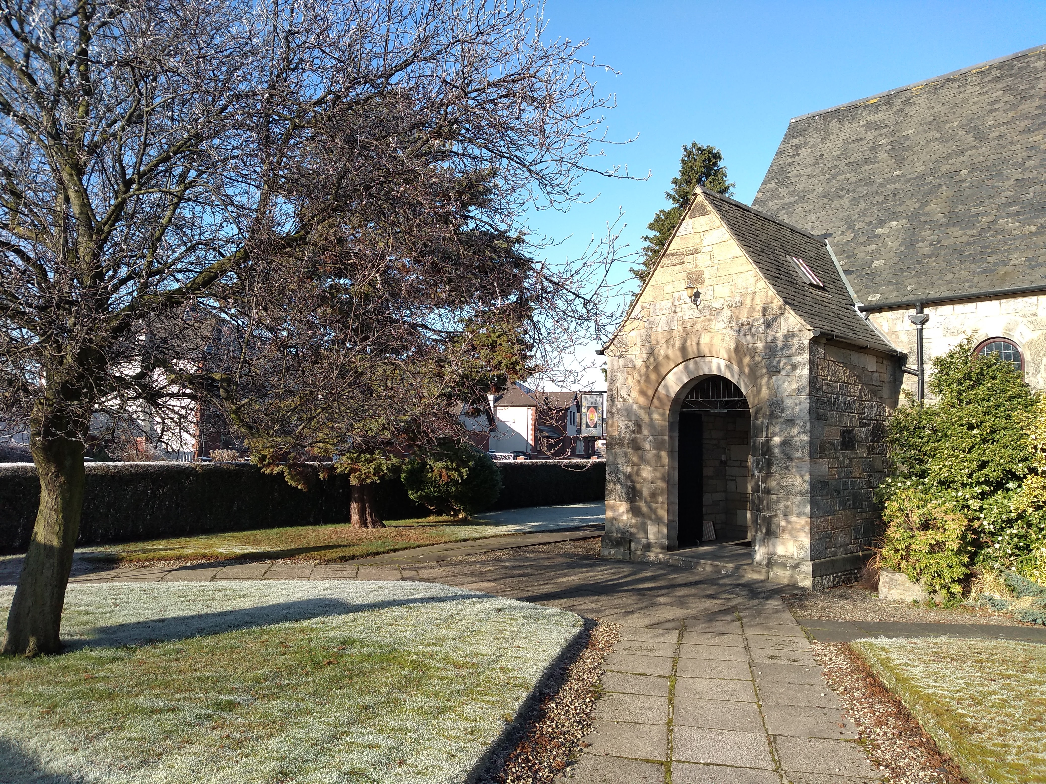
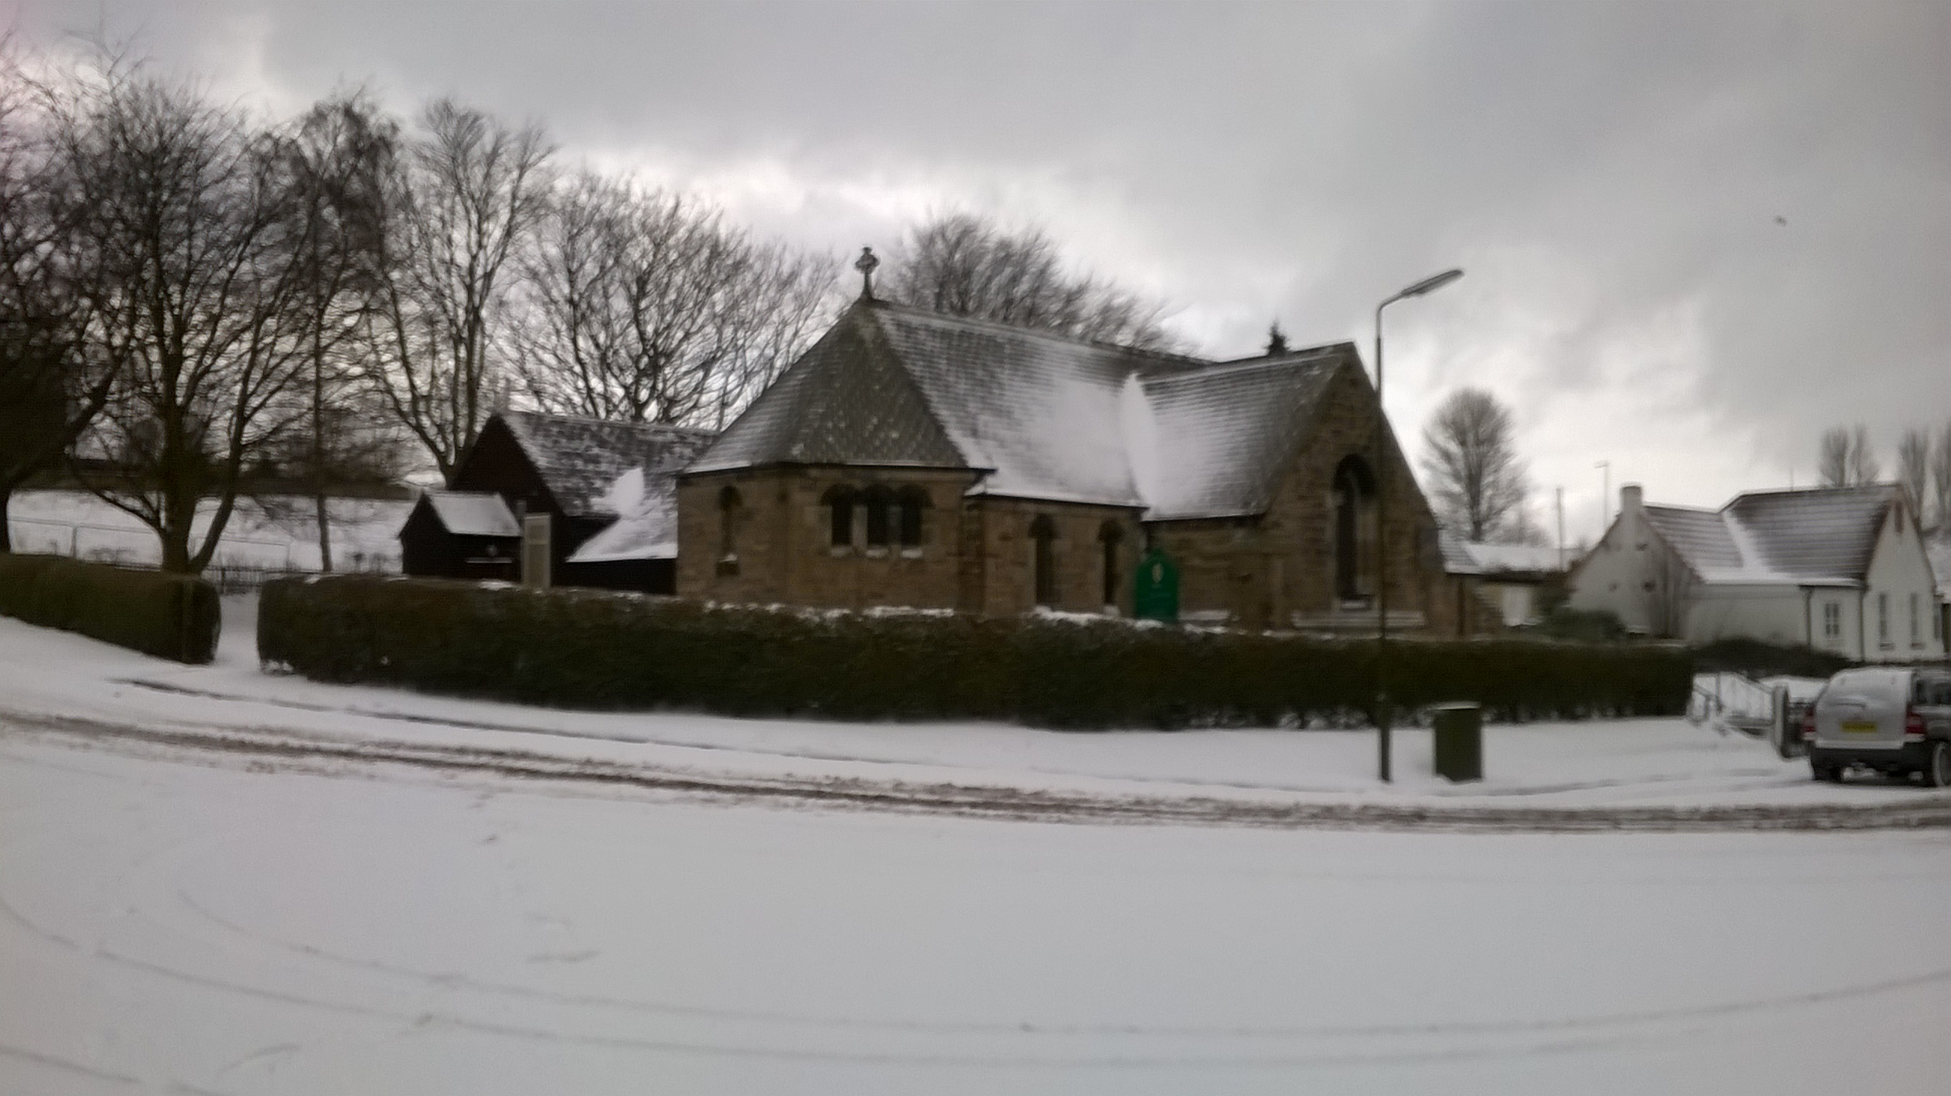

THE LINK, January 2021
““My name will be great among the nations, from where the sun rises to where it sets. In every place incense and pure offerings will be brought to me, because my name will be great among the nations,” says the Lord Almighty.” Malachi 1:11

Dear church family,
Epiphany is both a day and a season. Falling on the 6th January, it is the day we celebrate the arrival of the wise men to Bethlehem. It is then a season when we remember the life of Jesus as a boy and young man and the beginning of his ministry. Confusingly, it doesn't always work in a good chronological order – the first Sunday after Epiphany celebrates the Baptism of Christ and then, this year, the calling of Philip and Nathanael, the beginning of Jesus' ministry, the casting out of a demon, and then the season ends, as it always does, with Candlemas, when the child Jesus is brought to the temple and recognised by Simeon and Anna as the glory of Israel and the light to lighten the nations.

The theme of the Epiphany is of mysteries being revealed – the light dawning in darkness, beginning in Bethlehem and spreading to the whole world. Bright enough for all to see by, penetrating enough that all those who are living in darkness throughout the whole world can see a great light. It is a continuation of the themes initiated in Jesus birth – Emmanuel - God is here with us – the light of the world has come – all that was told of in the Old Testament finally coming to pass.

The quotation from Malachi above is very fitting for Epiphany – God will be revealed to all people as their loving Saviour and all will turn to him. This finds fulfilment in the wise men, Gentiles, coming from strange, unnamed lands, bringing their riches to worship the child Jesus. However, it is a bit of a misquotation because it lacks context. In that part of Malachi God is rebuking the people of Israel, “Oh that you would close the doors of the temple!” he says in verse 10. They were in a mess, personally and as a nation. The first thing Jesus and his family had to do after the wonder of the arrival of the wise men, was flee to Egypt. The darkness of that day tried hard to snub it out immediately.

Darkness is always the context in which we live in this world, these days have shown us that more clearly. Our doors have once again had to close so that what light there is might seem to be growing dimmer, even as the actual days are finally getting longer once again. The darkness spread by the coronavirus and the restrictions we all have to live under might seem to be an impenetrable cloak over our lives. But deep darkness was the context into which Jesus' light came and the Epiphany stories tell us how that light shone forth brightly, both to unexpected people and to people who did not expect it, and the joy that even a glimpse of it brought.

When God gave us the light of Jesus, he did not hide it or keep it for a few, but sent it out into the world. Wise men saw it, God's voice at Jesus' baptism confirmed it, Nathanael resting under the fig tree was changed by it, a demon possessed man was set free by it, two prayerful old people got the chance to hold the light of the world in their arms and proclaim the wonderful Good News to the nations that they'd always been waiting for. Your light has come!

Look for the light, it shines on you still. It comes to free us from fear and lead us to love and hope. May this light be revealed afresh to you and those you know and love at this season of Epiphany.

Blessings to you all, Willie

NOTICES

Susan is working with the Kersiebank Project on Wednesdays and Thursdays, currently based in the old Poundstretcher unit in Grangemouth Precinct. They have been operating a foodbank and face a constant struggle to provide food for around 70 families a week. You can drop items off at the rear of their unit. They would welcome donations of money, but are also particularly in need of tins of spaghetti, tins of potatoes, breakfast cereals and jars of pasta sauce. The Storehouse (the Bo'ness Foodbank) would also welcome donations. Both foodbanks will probably see increased demand following this new lockdown.

The Province recognise that holding any sort of an AGM at this time is hard and have given permission for there to be no AGMs held at this time. St Catharine's AGM therefore is postponed until we are able to meet in person. The vestry members are allowed to stay on if they wish to do so beyond their usual three years until the next meeting. Please let Willie know if you are happy to do this.

The services are now all online and will be available to view by each Sunday morning. You can find them on our Facebook Page and Group Page (search for St Catharine's and St Mary's), our website (stcatharinestmary.org.uk), or on YouTube (available on Virginmedia TV services as well as on PCs and phones – search for St Catharine's, Christ Church, St Mary's). It is possible to make DVDs of the services currently found online (a particular one or even all of them!) so that you could watch them without an internet connection. If you would like one of these distributed with your next Link or perhaps even each week then please let Willie or Susan know and we will get one to you.

Proposed dates for our next Zoom vestry meetings are St Mary's: Tuesday 12th January, 8pm and St Catharine's: Monday 18th January, 8pm.

Something to Look Forward to: Between St Mary's, St Catharine's and Christ Church, we're holding a Zoom Burns Night on Monday 25th January. Please let Willie know if you'd like to come or have something you'd like to contribute – further details will be announced on Facebook and our website nearer the time. You can eat your haggis along with us if you like or just bring your dram. There will be bagpipes!

Prayers

Epiphany Collect from the Scottish Prayer Book, 1929:
O God, who by the leading of a star didst manifest thy only-begotten Son to the Gentiles: Mercifully grant that we, which know thee now by faith, may after this life have the fruition of thy glorious Godhead; through Jesus Christ our Lord. Amen.

At St Mary’s we pray for Robin, Alice, Myra, Betty, Anna, and Alan.

At St Catharine’s we pray for Sally, Chrissie, Don, Pamela, Etta, Sadie, Greta, Rina, Kathleen, Hamish, Jack, Janette, Maureen, and Stuart.

Contact details

Rector: Rev Willie Shaw, stmarysandstcatharines@virginmedia.com, 01324 482438

Curate & Deacon: Rev Susan Ward, susanpward54@gmail.com, 07760 274272

